Artificial intelligence
Assignment
Roll No(124-BSCS/24-046)
Adeeba mehmood
12-29-2025

Question:1
Write a Python program that simulates a simple medical diagnosis system.
The program should:
Ask the user whether they have a fever, cough, and fatigue.
Based on the user’s answers:
If the user has both fever and cough, display: “Possible flu or COVID-19”
If the user has fatigue only, display: “Possible stress or tiredness”
Otherwise, display: “You seem to be fine”
Implement the logic using a function.

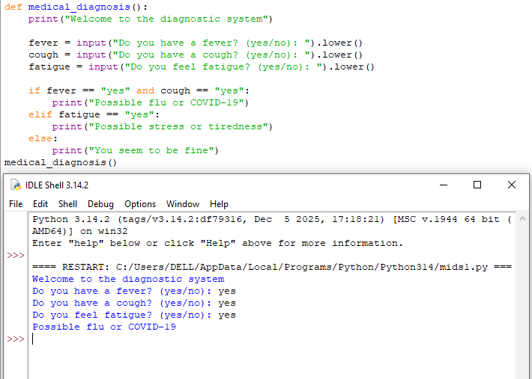

Question no 2: Create a Python program that uses randomness to suggest one activity to the user.
